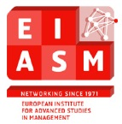
12TH WORKSHOP ON FAMILY FIRM MANAGEMENT RESEARCH
BRIDGING THE GAP –
INTEGRATING FAMILY BUSINESS THEORY & PRACTICE
Zwolle, The Netherlands MAY 12-14, 2016

CHAIRPERSONS
Ilse Matser, Karin Rozendal, Judith van Helvert, Chantal Remery, Magré Heetebrij, Windesheim University of Applied Sciences, Netherlands
Ethel Brundin, Mattias Nordqvist, Center for Family Enterprise and Ownership – CeFEO Jönköping International Business School, Sweden

Program
Thursday 12 May | 18.00-19.30 Welcome Reception - Opening words and Welcome: Ilse Matser  Museum de Fundatie (http://www.museumdefundatie.nl/?lang=eng)  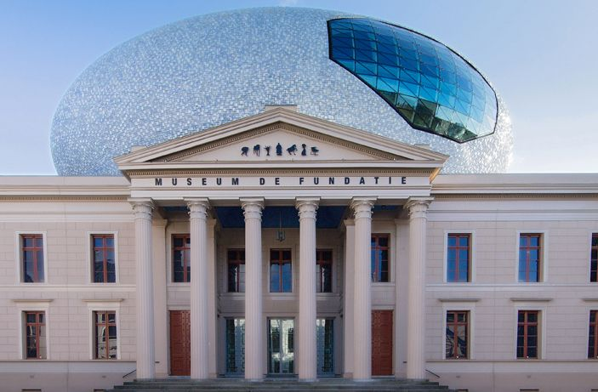
Friday  13 May | Conference day 1  08.00-12.00 Registration, Central Hall X building  08.30-8.45 Opening words and welcome, room X.177  Professor Albert W.C.A. Cornelissen, president of Windesheim University of Applied Sciences and Mattias Nordqvist, CeFEO Jönköping International Business School  08.45-9.30 Keynote presentation by Georges Romme, Professor of Entrepreneurship & Innovation, Eindhoven University of Technology - Toward a Design Science Perspective on Family Business Research, room X1.77  09.30-11.00 Parallel sessions 1, 2 and 3  11.00-11.30 Coffee break  11.30-13.00 Parallel sessions 4, 5 and 6  13.00-14.00 Lunch, Central Hall X building  14.00-15.30 Parallel sessions 7, 8 and 9  15.30-16.00 Coffee break  16.00-17.30 Parallel sessions 10, 11 and 12  19.00-20.00 Tour and reception in “Waanders”, bookstore (family business) located in old church (see also http://waandersindebroeren.nl/)  20.00- 23.00 Dinner and best paper award ceremony offered by FBNed, the Dutch chapter of FBN (www.fbned.nl)  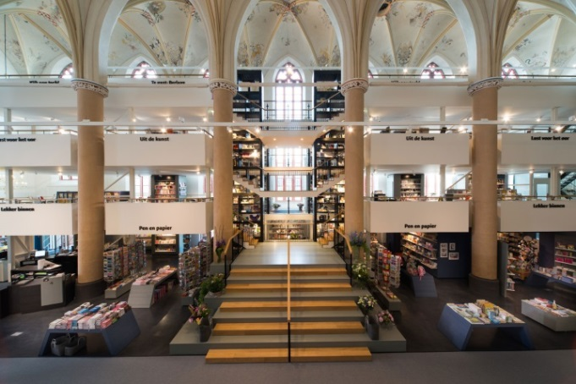
Saturday 14 May | Conference day 2  09.00-9.45 Keynote presentation by Peter Jaskiewicz, associate professor at Concordia University’s John Molson School of Business - Families in business: asset or liability? How differences in family structure affect family firm performance around the world, room X1.77  09.45-10.00 Coffee break  10.00-11.30 Parallel sessions 13 and 14  11.30-13.00 Parallel sessions 15 and 16  13.00-14.00 Lunch  14.00-15.15 Session: bridging the gap between theory and practice, room X.177  Live case Royal van der Most (http://www.vandermost.com/en/royal-van-der-most): interactive session with family business owner-managers, consultants and academics, moderated by Albert Jan Thomassen, managing director of FBNed  15.15-15.45 In conversation with Pramodita Sharma, professor at the Grossman School of Business, University of Vermont, room X1.77  15.45-16.00 Closing & welcome to the 2017 conference  16.00-16.30 Refreshments

SESSIONS
Session 1 Friday: 9.30-11.00 Room X1.90
Marketing and reputation - Chair: Peter Jaskiewicz
Title | Author | Co-Author(s)
SHOW UP OR HIDE AND SEEK? HOW FAMILY BUSINESSES USE THEIR STRENGTHS IN MARKETING AND COMMUNICATION | BERENT-BRAUN, MARTA | ROBERTO FLÖREN
CONCERN FOR FIRM REPUTATION: A SERIAL MULTIPLE MEDIATION MODEL OF FAMILY ANTECEDENTS. | VAN GILS, ANITA | JOLIEN HUYBRECHTS TOMMASO MINOLA LUCIO CASSIA
FOR THE GOOD OF THE FIRM AND THE FAMILY: MANAGING FAMILY (AND) BUSINESS REPUTATION, THE CASE OF A HOTEL BUSINESS | WIELSMA, ALBERTHA
Session 2 Friday: 9.30-11.00 Room X1.50
Institutional aspects - Chair: Lorraine Uhlaner
Title | Author | Co-Author(s)
WAGES, WAGE POLICY AND THE FAMILY FIRM: FIRM-LEVEL EVIDENCE ON THE NETHERLANDS | CREEMERS, SARAH | MARK VANCAUTEREN WIM VOORDECKERS BART LOOG
ALIGNING FAMILY-FIRM DUALITIES WITH INDUSTRY DUALITIES FOR COMPETITIVE ADVANTAGE | ACHTENHAGEN, LEONA | KAJSA HAAG
FAMILY BUSINESS RESEARCH – A MULTI THEORETICAL PERSPECTIVE | SINGH, RAJANI
Session 3 Friday: 9.30-11.00 Room X1.52
Agricultural family firms - Chair: Mattias Nordqvist
Title | Author | Co-Author(s)
A CONTEXTUAL VIEW OF ENTREPRENEURIAL FARMING FAMILIES: A LOOK THROUGH ENTREPRENEURIAL STEWARDSHIP | DISCUA CRUZ, ALLAN FERNANDO
FAMILY HUMAN CAPITAL, MARKET DYNAMICS, AND THE SUSTAINABILITY OF FAMILY OWNERSHIP AND CONTROL | GOTTSCHALL, RICHARD
HUMAN CAPITAL AND THE WILLINGNESS TO CONTINUE THE FAMILY FARM | BOUMA, JELLE | ARJEN DEKKER ERIK VELDHUIZEN ARJEN DEKKER

Session 4 Friday: 11.30-13.00 Room X1.90
Financial aspects I - Chair: EDDY LAVEREN
Title | Author | Co-Author(s)
WHICH INVESTOR FITS BEST TO FAMILY FIRMS? – A COMPARISON OF PRIVATE EQUITY AND FAMILY INVESTOR BEHAVIOR | THIELE, FELIX | OLAF ROTTKE
OWNERSHIP STRUCTURE, ASSET INTENSITY AND FIRM PERFORMANCE | WEISSKOPF, JEAN-PHILIPPE | PHILIPPE MASSET
HETEROGENEITY IN ORIGIN OF RUSSIAN FAMILY FIRMS: DOES IT MATTER FOR INNOVATION AND INVESTMENT ACTIVITY? | GOLIKOVA, VICTORIA | BORIS KUZNETSOV
Session 5 Friday: 11.30-13.00 Room X1.50
Knowledge and learning - Chair: Marie José Parada
Title | Author | Co-Author(s)
KNOWLEDGE INTEGRATION IN FAMILY FIRMS. AN EMPIRICAL ANALYSIS IN SPANISH FIRMS | BARROS, ISMAEL | JUAN HERNANGÓMEZ BARAHONA NATALIA MARTÍN CRUZ
DOES THE FAMILY NATURE OF A BUSINESS INFLUENCE THE RELATIONSHIPS BETWEEN LEARNING, MARKET AND ENTREPRENEURIAL ORIENTATIONS? | HERNÁNDEZ, REMEDIOS | REMEDIOS HERNÁNDEZ-LINARES Mª CONCEPCIÓN LÓPEZ-FERNÁNDEZ FRANZ W. KELLERMANNS SOUMODIP SARKAR
IMPACT OF CONFLICT MANAGEMENT STRATEGIES ON KNOWLEDGE TRANSFER AND SUCCESSION IN FAMILY BUSINESS | MLAKIC, TANJA
Session 6 Friday: 11.30-13.00 Room X1.52
Succession I - Chair: Pramodita Sharma
Title | Author | Co-Author(s)
BUILDING A LEGACY: CEO FOUNDER-SUCCESSION IN ASIA | ANG, SER KENG | SER-KENG ANG SIAN OWEN JO-ANN SUCHARD
COMMITMENT AND FAMILY BUSINESS CONTINUITY: INVESTIGATING THE MEDIATING ROLE OF FAMILY-TO-FIRM IDENTITY FIT AND EMOTIONAL ATTACHMENT | BASLY, SAMI | PAUL-LAURENT SAUNIER
FAMILY OR NON-FAMILY CEO? THIS IS THE QUESTION! THE ROLE OF COMPETITIVE RESOURCES AND TMT CONFIGURATIONS | CAMPOPIANO, GIOVANNA | ANDREA CALABRÒ RODRIGO BASCO
Session 7 Friday: 14.00-15.30 Room X1.90
Social and cultural aspects - Chair: Chantal Remery
Title | Author | Co-Author(s)
FAMILY LEADERSHIP AND CONTROL OF INTER-ORGANISATIONAL RELATIONSHIPS: A SOCIAL CAPITAL PERSPECTIVE | GLYPTIS, LOUKAS | ELIAS HADJIELIAS KOSTAS GALANAKIS
THE ROLE OF WOMEN IN FAMILY BUSINESS: EVIDENCE FROM THE ITALIAN CONTEXT | FARAUDELLO, ALESSANDRA | LUCREZIA SONGINI YULIYA PANKOVA
CORPORATE CULTURE IN FAMILY-OWNED WORLD MARKET LEADERS FROM AUSTRIA | JUNGWIRTH, GEORG
Session 8 Friday: 14.00-15.30 Room X1.50
Succession II - Chair: Marcela Ramirez-Pasillas
Title | Author | Co-Author(s)
OWNERSHIP PROTECTION AND EXIT IN FAMILY FIRMS: GOOD IN THEORY BUT HOW ABOUT PRACTICE? | HAAG, KAJSA | LARS-GÖRAN SUND, HANNA ALMLÖF
NEGOTIATING CONTINUITY: A CASE STUDY OF TRANSITIONS AND CULTURAL ELABORATION IN FAMILY BUSINESS | ADIGUNA, ROCKY
IN THE SPIDER'S WEB. A LONGITUDINAL CASE STUDY APPROACHING THE DYSFUNCTIONAL DYNAMICS IN FAMILY BUSINESSES | FERRARI, FILIPPO
Session 9 Friday: 14.00-15.30 Room X1.52
Financial aspects II - Chair: STEFAN PRIGGE
Title | Author | Co-Author(s)
FAMILY INFLUENCE ON EARNINGS SMOOTHING | KAISER, STEFANIE | MARTIN GLAUM
UNLISTED FAMILY FIRMS AND THE FINANCIAL-ECONOMIC CRISIS: DID THEY WEATHER THE GREAT RECESSION? | BROEKAERT, WOUTER | JOHAN LAMBRECHT BART HENSSEN
THE IMPACT OF PRIVATE EQUITY INVESTOR EXITS ON FAMILY-OWNED BUSINESSES | THIELE, FELIX | STEFAN PRIGGE SVEN BUSSE

Session 10 Friday: 16.00-17.30 Room X1.90
Governance - Chair: Anita van Gils
Title | Author | Co-Author(s)
HOW IS THE QUESTIONING OF EXISTING INSTITUTIONAL LOGICS MANAGED IN OWNER FAMILIES OF FAMILY FIRMS? | JUNGELL, LENA | JOAKIM WINCENT SARA THORGREN
INSTITUTIONALIZING GOVERNANCE STRUCTURES IN FAMILY BUSINESSES | PARADA, MARIA JOSE | ALBERTO GIMENO LEIF MELIN MATTIAS NORDQVIST
FEEDBACK SEEKING BEHAVIOR AND DEFENSIVE ROUTINES AT WORK IN ADVISORY BOARDS IN FAMILY FIRMS: EXPLORING THE ROLE OF MINDSETS | VAN HELVERT-BEUGELS, JUDITH
Session 11 Friday: 16.00-17.30 Room X1.50
Family capital - Chair: CAROLE HOWORTH
Title | Author | Co-Author(s)
CONSCIOUS ALIGNMENT OF FAMILY BUSINESS VALUES DURING GENERATIONAL TRANSITION, "REINVENTING THE SYSTEM AS CONDITIONS CHANGE" | VAN ZWOL, JACQUELINE
KNOWLEDGE INTEGRATION IN FAMILY FIRMS. AN EMPIRICAL ANALYSIS IN SPANISH FIRMS | BARROS, ISMAEL | JUAN HERNANGÓMEZ BARAHONA NATALIA MARTÍN CRUZ
Session 12 Friday: 16.00-17.30 Room X1.52
Succession III - Chair: Shelley Farrington
Title | Author | Co-Author(s)
CONTINUITY AND CONNECTION AS BEHAVIORAL CHARACTERISTICS OF FAMILY FIRMS: ANALYSIS ON THE LIFE-CYCLE MANAGEMENT IN THE JAPANESE PHARMACEUTICAL INDUSTRY | ASABA, SHIGERU | TAICHIRO YANABE
GROWTH ATTRIBUTES – CLOSING THE GAP IN FAMILY-SMES | NEVILLE, METTE | TOVE BRINK

Session 13 Saturday: 10.00-11.30 Room X1.50
Entrepreneurship - Chair: Alan Discua Cruz
Title | Author | Co-Author(s)
THE MODERATING EFFECT OF THE BUSINESS FAMILY ON OPPORTUNITY INTENTION AND OPPORTUNITY BELIEFS AMONG COLLEGE STUDENTS | LORENZO-GOMEZ, JOSE DANIEL | ÁLVARO ROJAS-VÁZQUEZ
FAMILY INFLUENCE ON NEXT GENERATIONS’ ENTREPRENEURIAL PROCESSES: MODERATING EFFECT OF INCORPORATION TO FAMILY FIRM | LORENZO-GOMEZ, JOSE DANIEL | ÁLVARO ROJAS-VÁZQUEZ
FAMILY INFLUENCE AND THE RECOGNITION OF AND ACTION ON ENTREPRENEURIAL OPPORTUNITIES: AN EXPLORATORY ANALYSIS | NÚÑEZ-CACHO, PEDRO | ROJAS, ALVARO LORENZO, DANIEL
Session 14 Saturday: 10.00-11.30 Room X1.52
Innovation and sustainable entrepreneurship - Chair: Giovanna Campopiano
Title | Author | Co-Author(s)
FAMILY FIRMS’ APPROACH TO GREEN INNOVATION: AN EXPLORATORY STUDY AMONG ITALIAN SMES | DANGELICO, ROSA MARIA | SIMONE PISA
THE INNOVATION CONDITION | SCHMITT, GREGOR
SUSTAINABLE ENTREPRENEURSHIP: DOING GOOD BY DOING NEW THINGS | SCHERRER, SYLVIE

Session 15 Saturday: 11.30-13.00 Room X1.50
Psychological aspects - Chair: Ethel Brundin
Title | Author | Co-Author(s)
FAMILY BUSINESS DIAGNOSTICS | WEISS, DAN
TEAM PSYCHOLOGICAL SAFETY IN TEAM ENTREPRENEURSHIP IN THE FAMILY BUSINESS: A DYNAMIC PERSPECTIVE | HADJIELIAS, ELIAS | CAROLE HOWORTH, ELEANOR HAMILTON
PERSONALITY TRAITS OF NONFAMILY CEOS IN FAMILY FIRMS: AN EXPLORATORY STUDY | KELLECI, RUVEYDA | FRANK LAMBRECHTS WIM VOORDECKERS JOLIEN HUYBRECHTS
Session 16 Saturday: 11.30-13.00 Room X1.52
Internationalization - Chair: Andrea Calabro
Title | Author | Co-Author(s)
FAMILY EMBEDDEDNESS IN IMMIGRANTS’ VENTURE DEVELOPMENT PROCESS | EVANSLUONG, QUANG | MARCELA RAMÍREZ-PASILLAS
INTERNATIONALIZATION OF FAMILY FIRMS: HOW TO EXPLAIN DIFFERENT ENTRY MODE CHOICES AND KNOWLEDGE TRANSFER STRATEGIES? | BRUMANA, MARA | DAVIDE GAMBA TOMMASO MINOLA LUCIO CASSIA
WHAT MAKES SOME FAMILY FIRMS EXIT FROM EXPORT MARKETS? | KUIKEN, ANDREA | LUCIA NALDI MATTIAS NORDQVIST

Maps
Train station to Museum de Fundatie
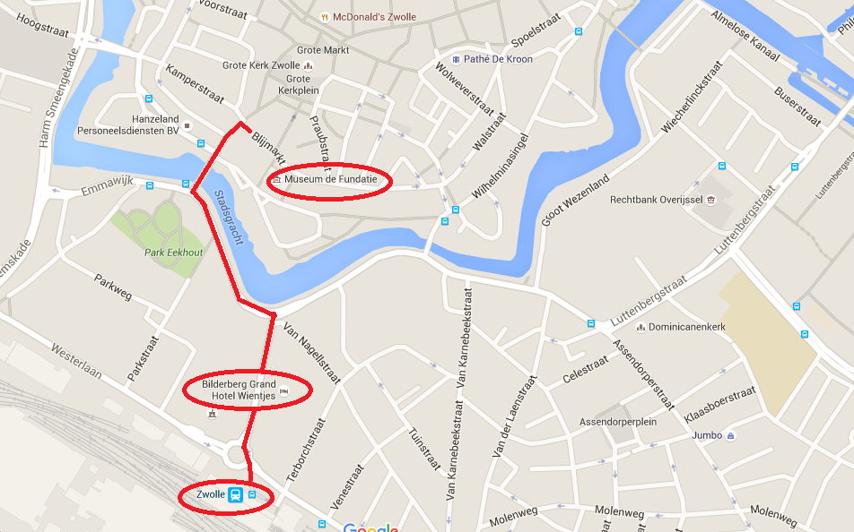
Train station to diner location “Waanders”, bookstore
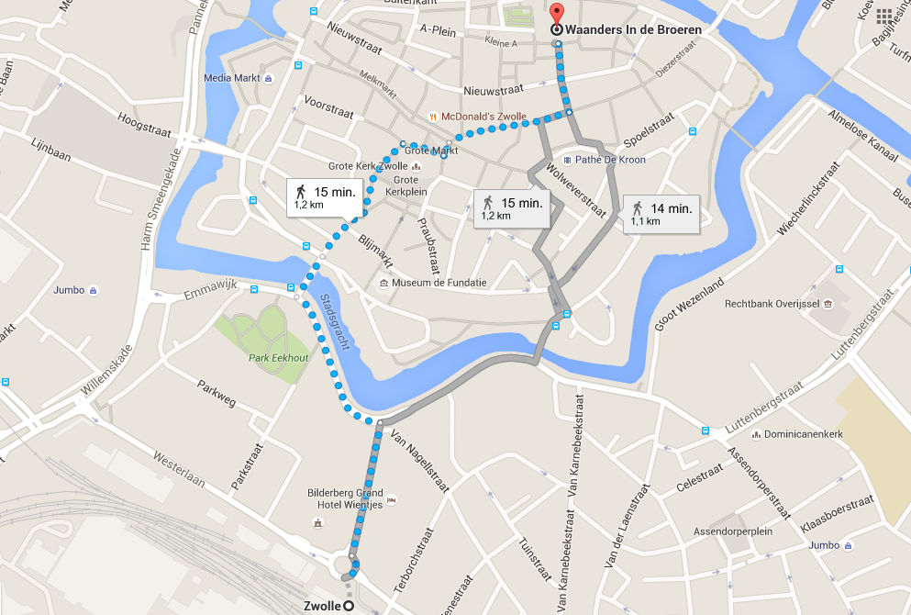
Train station to Windesheim Campus
